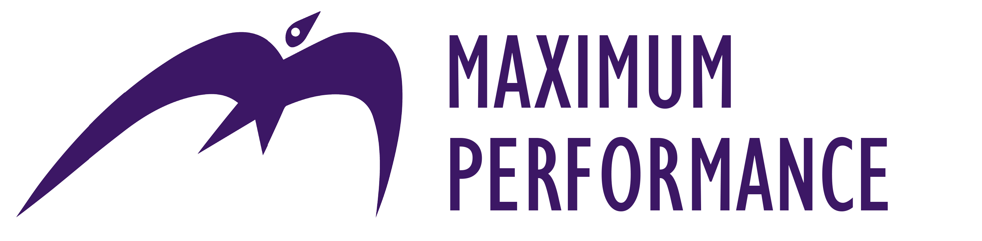
Management Development Programme

BOOKING FORM

CONTACT DETAILS (PLEASE TYPE)
Name (first name, surname): type here
Job title: type here
Organisation: type here
Address: type here
Email: type here
Tel: type here | Mob: type here
To process your booking we will need to put your details on our database. Please double-click here (then click ‘checked’) if you do not wish to be advised about future events or special offers:

BOOKING |  | COHORT | PRICE
Please invoice me for the following places: |  | (Delete as applicable)
1 | Type name of person attending here | Autumn 2023 / Spring 2024 | £2,995 + VAT
 | Type job title here
 | Type email address here
2 | Type name of person attending here | Autumn 2023 / Spring 2024 | £2,995 + VAT
 | Type job title here
 | Type email address here
Date of booking: type here |  | We will invoice you for payment within 28 days or no later than two weeks before the start of the course, whichever is the sooner.

Please email your completed booking form to helen.nuttall@maximumperformance.co.uk

Any questions? Please call Helen Nuttall on 01582 463460.

Terms and conditions
The fee includes all course materials. We reserve the right to refuse admission to the Zoom sessions if payment has not been received. A full refund will be made for cancellations received in writing at least 20 working days prior to the first session date; no refund can be given for cancellations made within 20 working days of the start of the programme. We reserve the right to change the programme, the dates, the trainers or the materials: participants will be notified as soon as practicable in such circumstances. In the event that the programme is cancelled or postponed, a full refund will be given. We disclaim any further liability.

